

PROJECT

# A Statistical Approach to Adult Census Income

**-Mohit Singh**

Project in computational Science: Report

MAY 2023

REPORT

Lovely Professional university

**A Statistical Approach to Adult Census Income**

**MASTER OF TECHNOLOGY**

**in**

**COMPUTER SCIENCE AND ENGINEERING**

By

**MOHIT SINGH**

**12013468**

Supervisor

**Ved Prakash Chaubey**



**School of Computer Science and Engineering**

Lovely Professional University

Phagwara, Punjab (India)

Month - MAY Year 2023

**DECLARATION STATEMENT**

I hereby declare that the research work reported in the dissertation/dissertation proposal entitled " A Statistical Approach to Adult Census Income ” in partial fulfilment of the requirement for the award of Degree for Bachelor of Technology in Computer Science and Engineering at Lovely Professional University, Phagwara, Punjab is an authentic work carried out under supervision of my research supervisor Mr./Mrs. Ved Prakash Chaubey. I have not submitted this work elsewhere for any degree or diploma.

I understand that the work presented herewith is in direct compliance with Lovely Professional University’s Policy on plagiarism, intellectual property rights, and highest standards of moral and ethical conduct. Therefore, to the best of my knowledge, the content of this dissertation represents authentic and honest research effort conducted, in its entirety, by me. I am fully responsible for the contents of my dissertation work.

*Signature of Candidate*

**Mohit Singh**

**12013468**

**SUPERVISOR’S CERTIFICATE (16 bold)**

This is to certify that the work reported in the B.Tech Dissertation/dissertation proposal entitled “**A Statistical Approach to Adult Census Income”**, submitted by **Mohit Singh** at **Lovely Professional University, Phagwara, India** is a Bonafede record of his original work carried out under my supervision. This work has not been submitted elsewhere for any other degree.

Signature of Supervisor

(Name of Supervisor)

**Date:**

**Counter Signed by:**

1. **Concerned HOD:**

HoD’s Signature: ________________

HoD Name: ____________________

Date: ___________________

1. **Neutral Examiners:**

**External Examiner**

Signature: _______________

Name: __________________

Affiliation: ______________

Date: ___________________

**Internal Examiner**

Signature: _______________

Name: __________________

Date: ___________________

# Abstract

The prominent inequality of wealth and income is a huge concern especially in the United States. The likelihood of diminishing poverty is one valid reason to reduce the world's surging level of economic inequality. The principle of universal moral equality ensures sustainable development and improve the economic stability of a nation. Governments in different countries have been trying their best to address this problem and provide an optimal solution. This study aims to show the usage of machine learning and data mining techniques in providing a solution to the income equality problem. The UCI Adult Dataset has been used for the purpose. Classification has been done to predict whether a person's yearly income in US falls in the income category of either greater than 50K Dollars or less equal to 50K Dollars category based on a certain set of attributes.

Lovely Professional university



|  |  |
| --- | --- |
| **Table of Contents** |  |
| **Abstract** | **I** |
| **List of Figures** | **II** |
| **1 Introduction** | **4** |
| **2 Theoretical Background** | **5** |
| 2.1 Supervised and Unsupervised Learning. . . . . . . . . . . . . . . . . . . . | 5 |
| 2.2 Machine Learning Algorithm Types. . . . . . . . . . . . . . . . . . . . . . | 5 |
| 2.3 Bias-Variance-Trade-off. . . . . . . . . . . . . . . . . . . . . . . . . . . . . . . . | 6 |
| **3 Problem Statement** | **7** |
| **4 Methodology** | **8** |
| 4.1 Data Review . . . . . . . . . . . . . . . . . . . . . . . . . . . . . . . . . . . | 8 |
| 4.2 Data Visualization. . . . .. . . . . . . . . . . . . . . . . . . . . . . . . . . . . | 8 |
| 4.3 Feature Study and Selection . . . . . . . . . . . . . . . . . . . . . . . . . | 12 |
| 4.4 Splitting Dataset and Modeling . . . . . . . . . . . . . . . . . . . . . . | 12 |
| **5 Conclusion** | **13** |
| **6 Code** | **20** |
| **7 Reference** | **24** |

Lovely Professional university

# 1 Introduction

Over the last two decades, humans have grown a lot of dependence on data and information in society and with this advent growth, technologies have evolved for their storage, analysis and processing on a huge scale. The fields of Data Mining and Machine Learning have not only exploited them for knowledge and discovery but also to explore certain hidden patterns and concepts which led to the prediction of future events, not easy to obtain. The problem of income inequality has been of great concern in the recent years. Making the poor better off does not seem to be the sole criteria to be in quest for eradicating this issue. People of the United States believe that the advent of economic inequality is unacceptable and demands a fair share of wealth in the society. This model actually aims to conduct a comprehensive analysis to highlight the key factors that are necessary in improving an individual's income. Such an analysis helps to set focus on the important areas which can significantly improve the income levels of individuals. This paper has been structured as an introduction, literature review, proposed methodology, training the model, implementation details, results and conclusion

Lovely Professional university

# 2 Theoretical Background

### Supervised and Unsupervised Learning

Supervised learning: "Supervised learning is a type of machine learning algorithm that uses a known dataset (called the training dataset) to make predictions. The training dataset includes input data and response values.", [4].

Unsupervised learning: "Unsupervised learning is a type of machine learning algorithm used to draw inferences from datasets consisting of input data without labeled responses.",[5].

In data mining and machine learning an abundance of models and algorithms can be found, but most fundamentally these are divided into supervised and unsupervised learning. One fundamental example has been mentioned in the foregoing section, the clustering of *iris*-species. Former is a supervised process where data points are labeled ("species A", "species B" or "species C") and labels are calculated for new data points. Comparing calculated labels according to the trained model with the original label gives the model’s accuracy, hence supervised.

Unsupervised learning on the other hand does not require any labeling, since the algorithm is searching for a pattern in the data. This might be useful when categorizing customers into different groups without a priori knowledge of which groups they belong to.

### Machine Learning Algorithm Types

For machine learning many different algorithms can be found. A wide variety of these are available in Azure Machine Learning Studio. For simplicity these can be subdivided into four categories, where each category is good for different kind of problems. **Anomaly detection** algorithms, are good for finding unusual data points. Trained **classification** algorithms can be used to categorize unseen data. As an example, it could be used to take in data from a phone on movement to categorize what activity is being performed. **Clustering** algorithms group data into clusters and look for the greatest similarities. This can be used to find unknown connections on huge sets of data. **Regression** algorithms are used to find patterns and build models to predict numerical values from datasets. These will take multiple inputs and determine how much each input affects the output

Lovely Professional university

Within the regression category there are eight different basic algorithms, each suitedfor different kind of problems, available in Azure Machine Learning Studio. **Boosted decision tree regression**, which is based on decision trees, where each tree depends on prior trees, uses decision splitting to create stepped functions. It learns by fitting the residuals of preceding trees to improve accuracy. **Decision forest regression** consistsof decision trees in regression and is resilient against noise, due to the fact that manytrees form a "forest". This makes it easily to parallelize. **Fast forest quantile regression** is effective in predicting weak relationships between variables. Unlike linear regression quantile algorithms try to find patterns in the distribution of the predicted values rather than just predict values. **Linear Regression** is the most classic type which solves linear relationships between inputs and outputs. **Neural network regression** is most common in deep learning and adaptable to regression problems, but might be too complex for simple regression problems and requires thorough training. This method is very stable and is often used when other algorithms can not find a solution. **Ordinal regression** is found useful for predicting discrete ranking. **Poisson regression** is useful to predict values if the response variable follow a Poisson distribution.

In general it should be noted, that the algorithms from Microsoft are not open source and it is therefore impossible to completely comprehend the underlying mechanisms.

### Bias-Variance-Trade-off

A problem in machine learning is to find a balanced compromise between training accuracy and validation accuracy. This means to find a function that solves a training problem accurately, e.g. a high-degree polynomial that fits the training data well, butis not overfitting the validation data. On the other hand, a function too simple can oversimplify (underfit) a problem and neglect present patterns. This is a problem evident only in supervised learning and therefore relevant for regression analysis. The dilemma often leads to trial-and-error strategies of finding suitable models [3].



# 3 Problem Statement

We have to predict the income of a person whether he/she is earning more than 50k or less then 50k on the basis of certain factors like age, work class, education, marital status, occupation, relationship, race, sex, hours per week, native country etc using different machine learning algorithm.

# 4 Methodology

## Data Review

The data for our study was accessed from the University of California Irvine (UCI) Machine Learning Repository [8]. It was actually extracted by Barry Becker using the 1994 census database. The data set includes figures on 48,842 different records and 14 attributes for 42 nations. The 14 attributes consist of 8 categorical and 6 continuous attributes containing information on age, education, nationality, marital status, relationship status, occupation, work classification, gender, race, working hours per week, capital loss and capital gain as shown in Table 1. The binomial label in the data set is the income level which predicts whether a person earns more than 50 Thousand Dollars per year or not based on the given set of attributes

## Data Visualization

The exploratory data analysis is done to get the insight about the data and get to know about the feature dependency.

* + - Bar plot which shows the distribution of null values of data set. It can be inferred from the plot that only occupation workplace and native country have null values

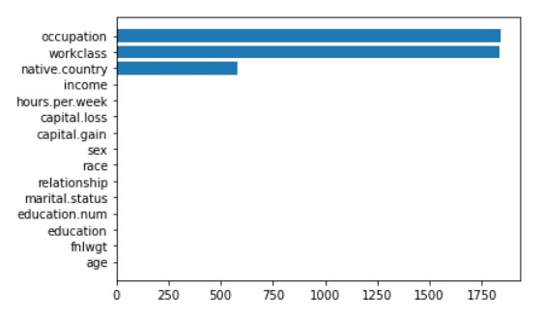

### FIG(1)

* + - Bar plot which shows the distribution of unique value of data set.

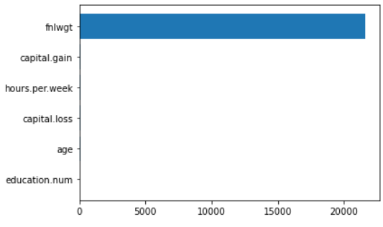

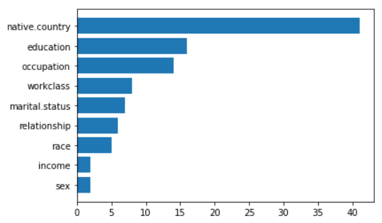

### FIG(2)

* + - Pie chart which shows the distribution of income. It can be inferred from the chart that more than 75% income is less than 50k

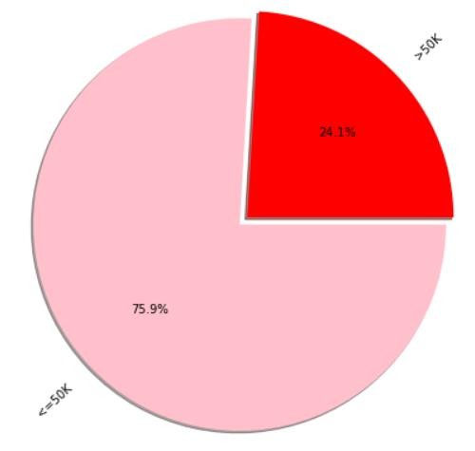

**FIG(3)**

* + - Pie chart which shows the distribution of work class . It can be inferred from the chart that more than 73% income is private class

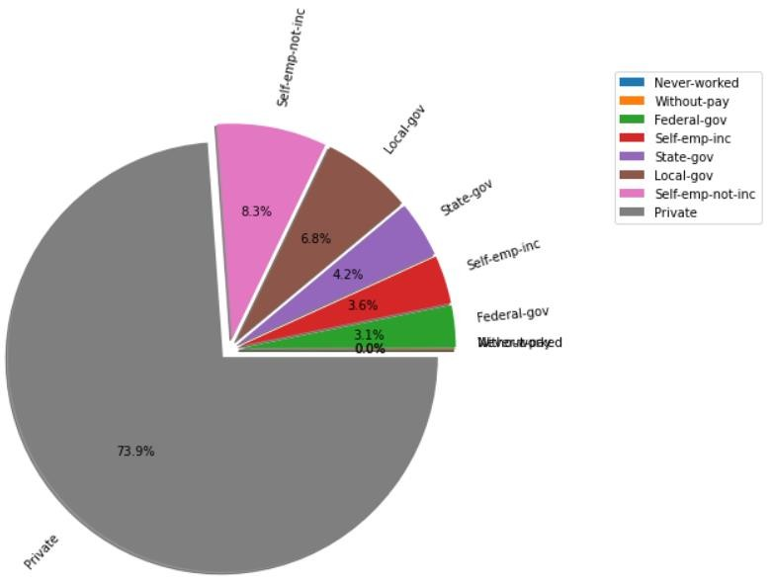

**FIG(4)**

* + - Histogram chart which shows the distribution of work class with respect to income. It can be inferred from the chart that private class has more number of income source and more number of person who has earning more than 50k and less than 50k

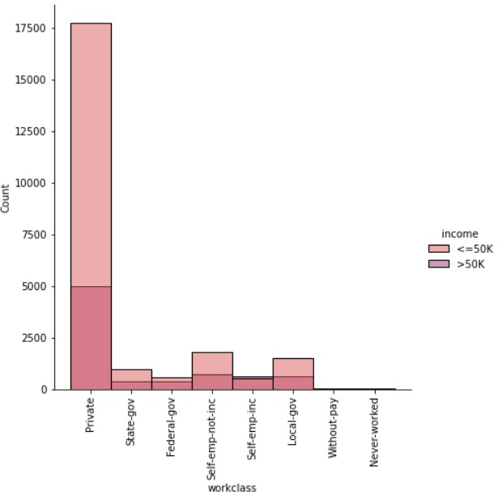

**FIG(5)**

* + - Pie chart which shows the distribution of Education . It can be inferred from the chart that more than 32% are educated in High Secondary Graduation

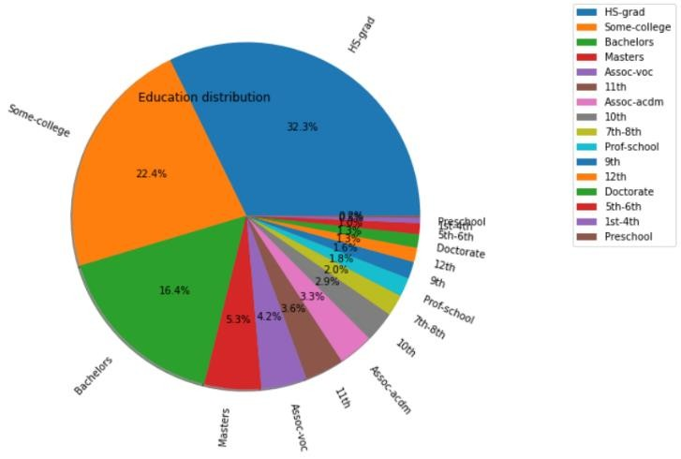

**FIG(6)**

## Feature Study and Selection

A Correlation Matrix is shown in the form of a HeatMap showing Feature-to-Feature and Feature-to-Label Pearson Correlations where all the features are Continuous Variables.

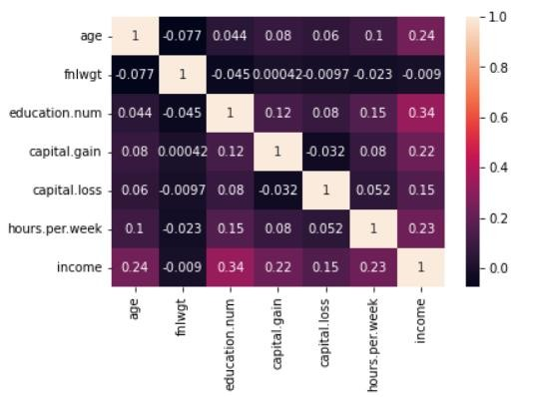

**FIG(7)**

**Heat-Map showing Feature-to-Feature and Feature-to-Label’s Pearson Correlation Coefficients**

.

## SPLITTING DATASET AND MODELLING:-

The shape of the dataset after the deletion of the duplicates is (32537, 15). The dataset is split where 70% is the used for training the model and 30% for testing the model. Hence out of 32,537 data entries, 21,485 are used for training and 9,209 are used for testing the model. 1 Classification Algorithms are used.

## 4.4.1 Logistic Regression

Logistic regression is a statistical model that in its basic form uses a logistic function to model a binary dependent variable. In regression analysis, logistic regression is estimating the parameters of a logistic model (a form of binary regression). Logistic regression is the appropriate regression analysis to conduct when the dependent variable is dichotomous (binary). Like all regression analyses, the logistic regression is a predictive analysis. Logistic regression is used to describe data

## 4.4.2 RandomForest Classifier

## Random Forest is a popular machine learning algorithm that belongs to the supervised learning technique. It can be used for both Classification and Regression problems in ML. It is based on the concept of ensemble learning, which is a process of combining multiple classifiers to solve a complex problem and to improve the performance of the model

## As the name suggests, "Random Forest is a classifier that contains a number of decision trees on various subsets of the given dataset and takes the average to improve the predictive accuracy of that dataset." Instead of relying on one decision tree, the random forest takes the prediction from each tree and based on the majority votes of predictions, and it predicts the final output.

## 4.4.3 BernoulliNB

## Bernoulli Naïve Bayes is another useful naïve Bayes model. The assumption in this model is that the features binary (0s and 1s) in nature. An application of Bernoulli Naïve Bayes classification is Text classification with ‘bag of words’ model. The Scikit-learn provides sklearn.naive_bayes.BernoulliNB to implement the Gaussian Naïve Bayes algorithm for classification.

## 4.4.4 Support Vector Classifier

Support Vector Machine or SVM is one of the most popular Supervised Learning algorithms, which is used for Classification as well as Regression problems. However, primarily, it is used for Classification problems in Machine Learning.

The goal of the SVM algorithm is to create the best line or decision boundary that can segregate n-dimensional space into classes so that we can easily put the new data point in the correct category in the future. This best decision boundary is called a hyperplane.

5 CONCLUSION AND FUTURE SCOPE

This paper proposed the application of Ensemble Learning

Algorithm, on Adult Census Data.

Finally, the Validation Accuracy, so obtained, **84.4%** which

is, by the best of our knowledge, has been the highest ever

numeric accuracy achieved by any Income Prediction Model

so far. The future scope of this work involves achieving

an over-all better set of results by using hybrid models

with inclusion of Machine Learning and Deep Learning

together, or by applying many other advanced preprocessing

techniques without further depletion in the accuracy.

# 6 CODE

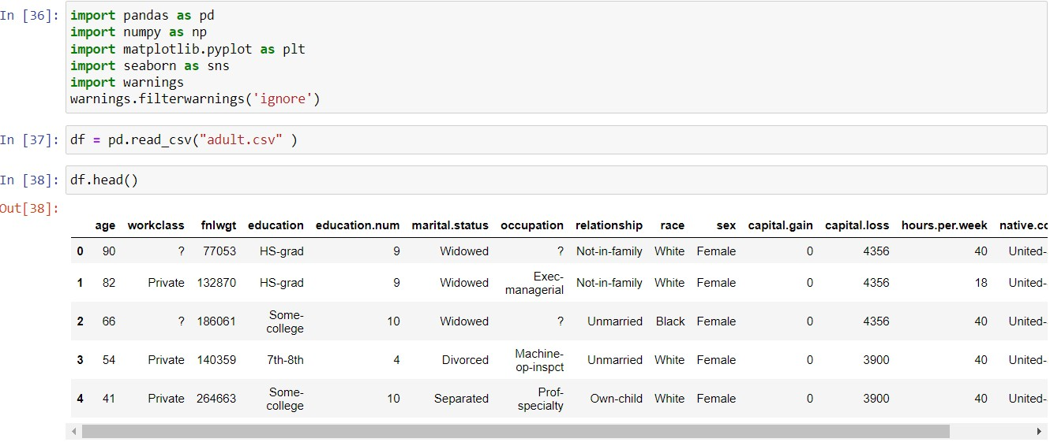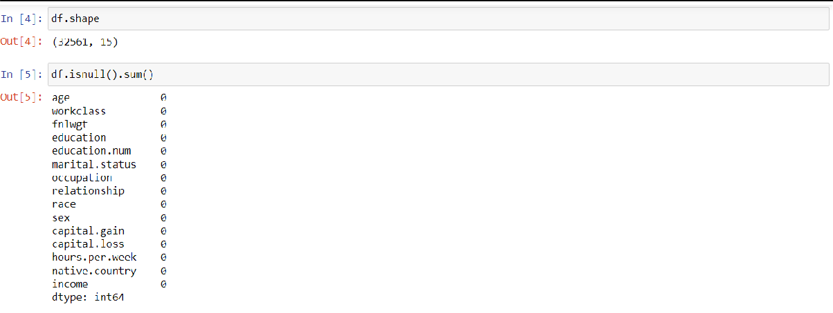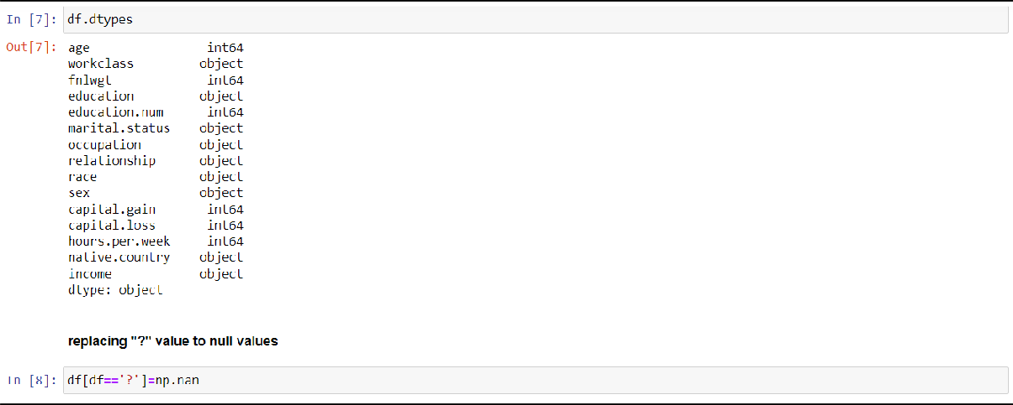



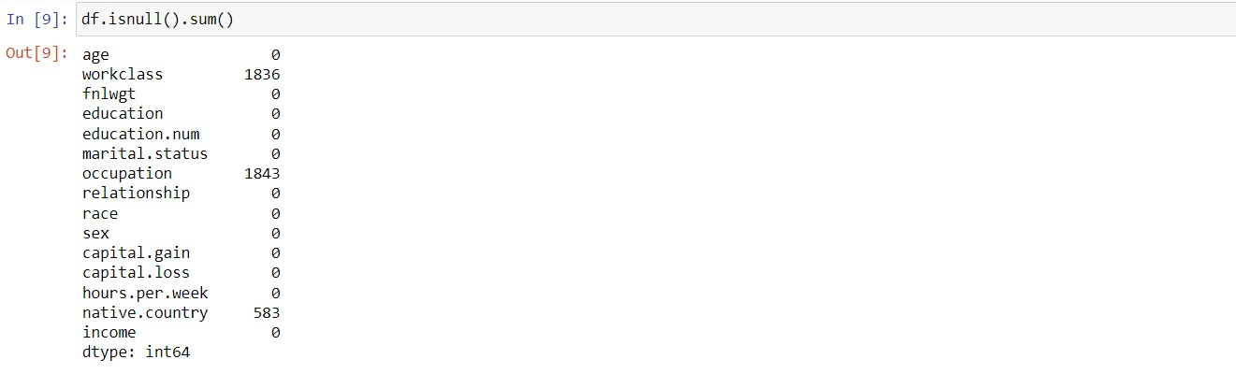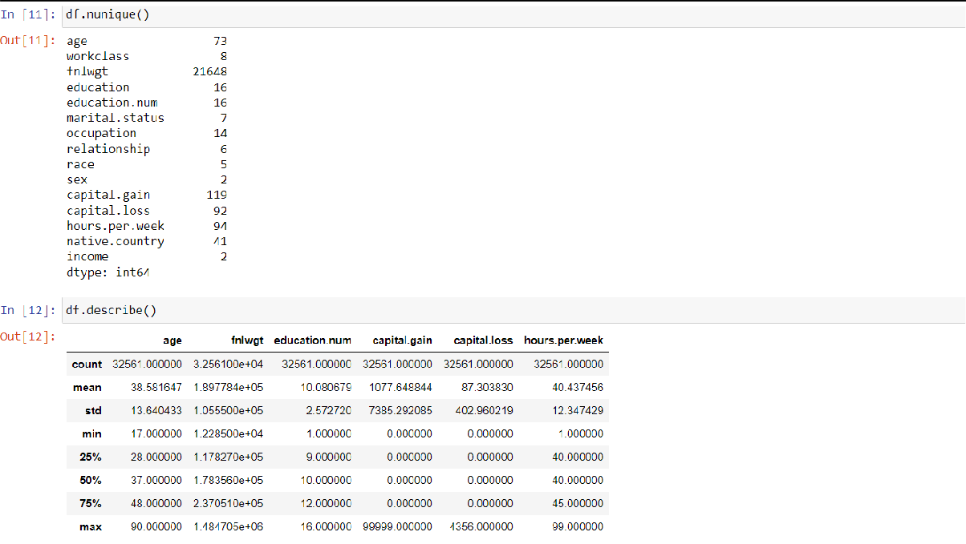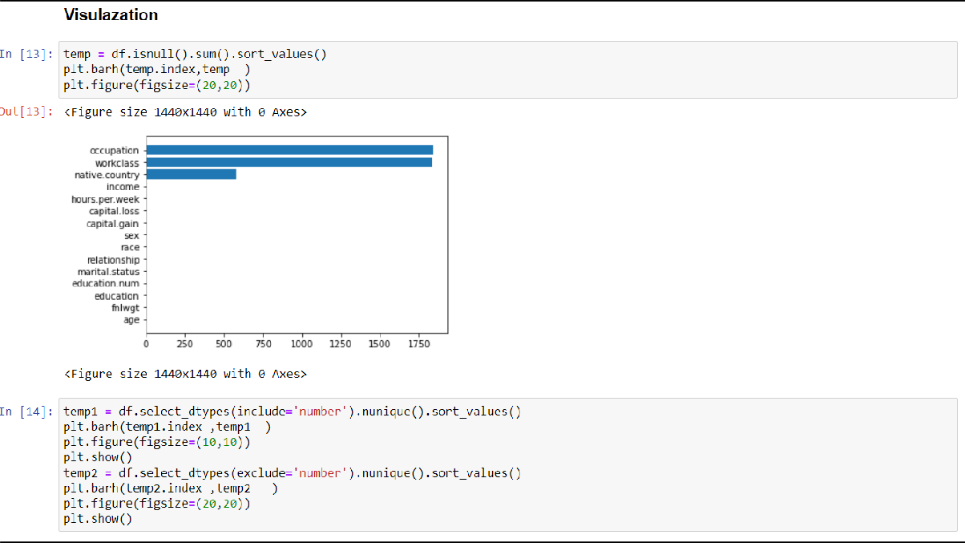

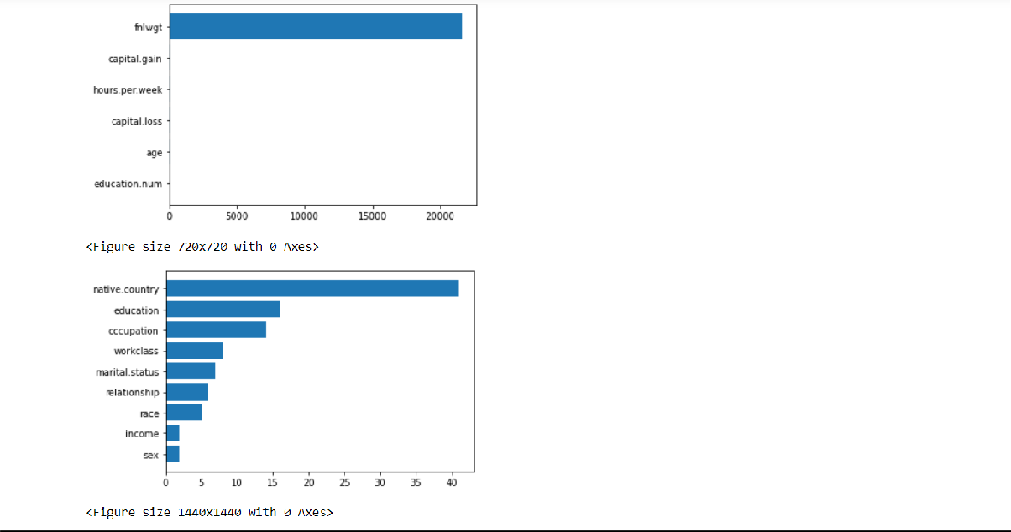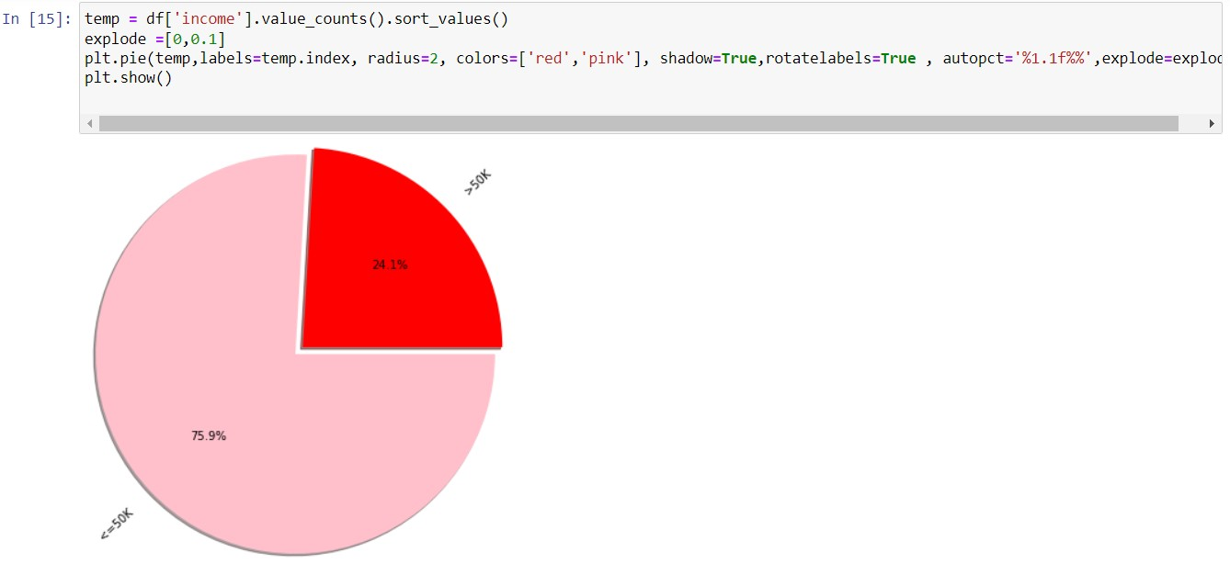



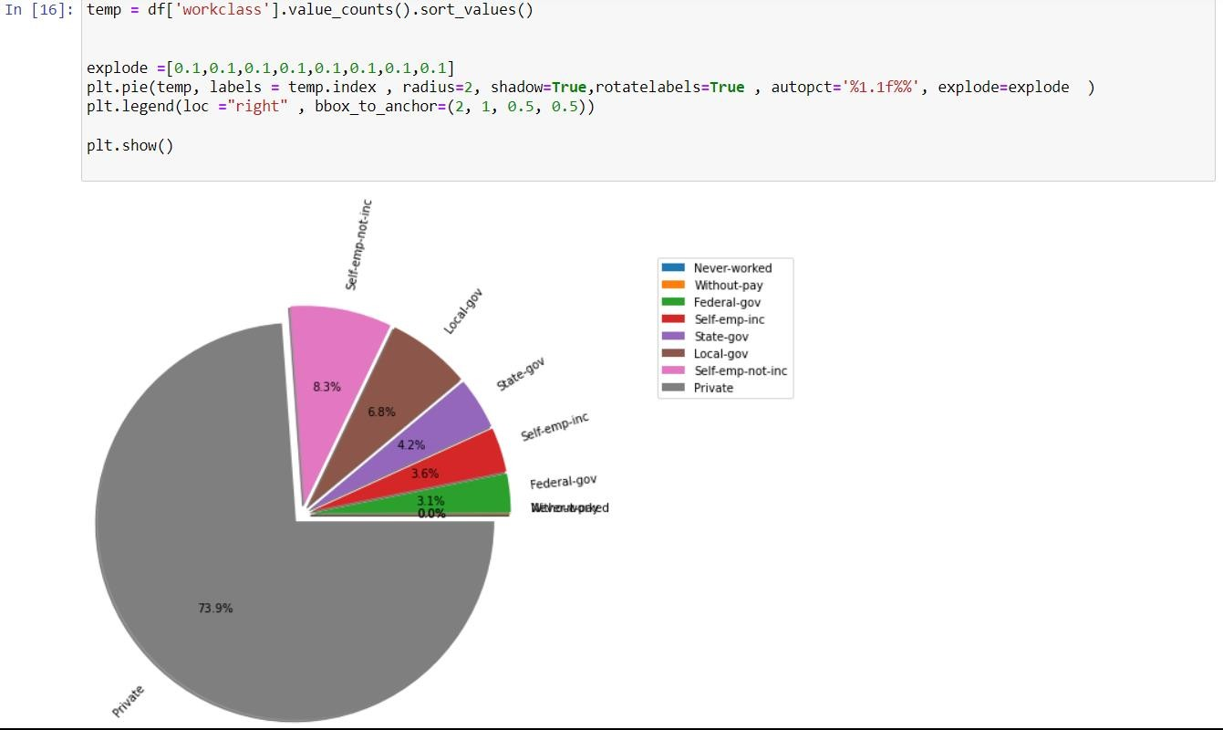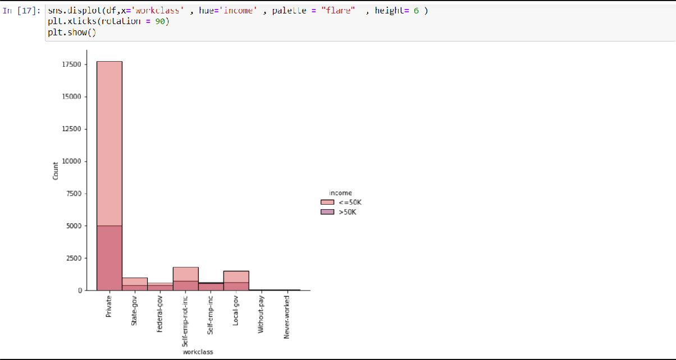

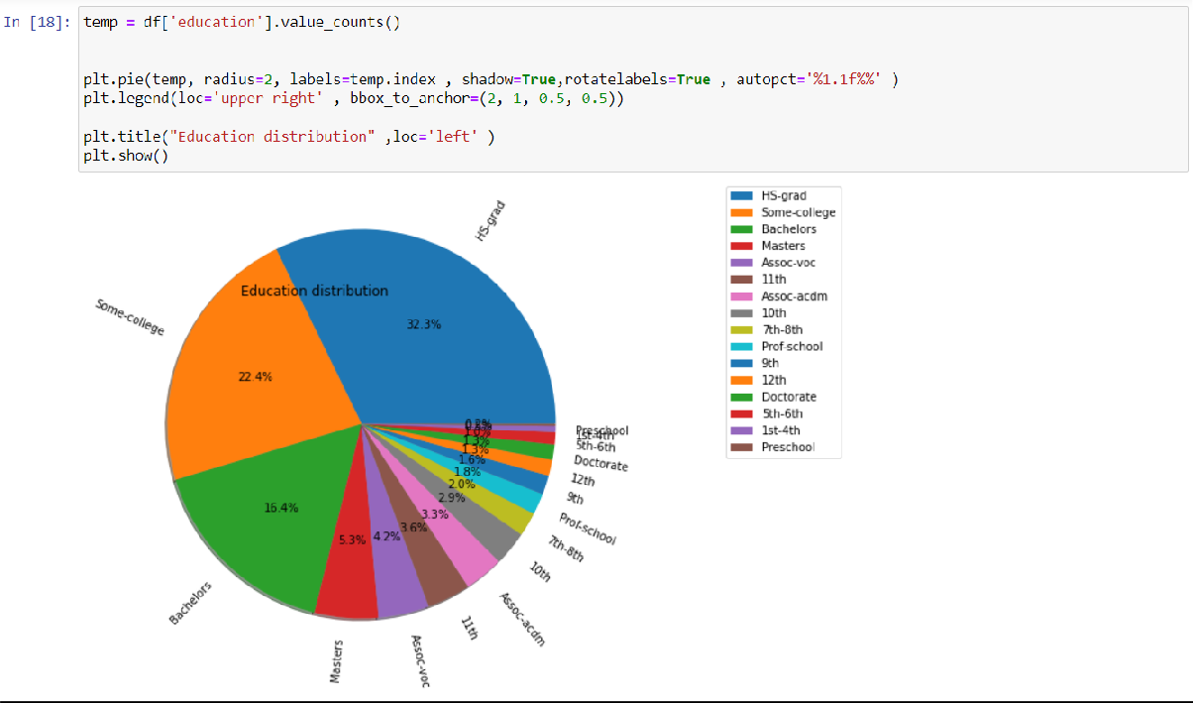



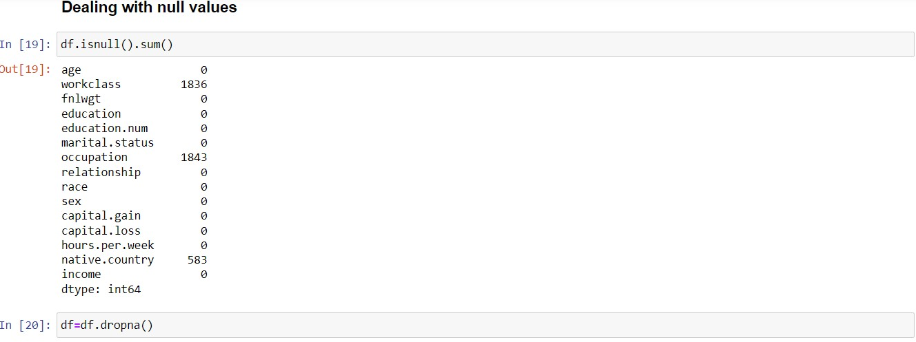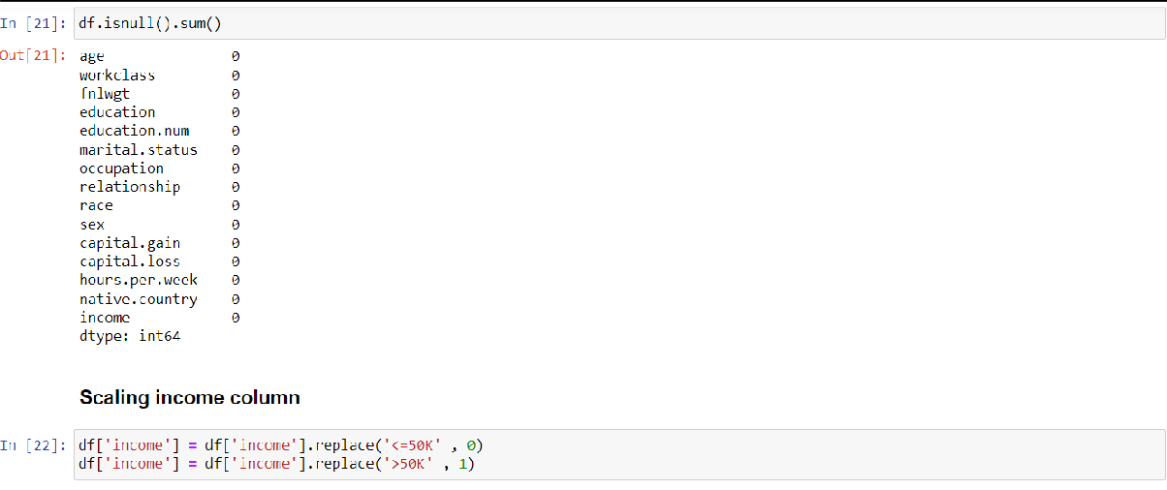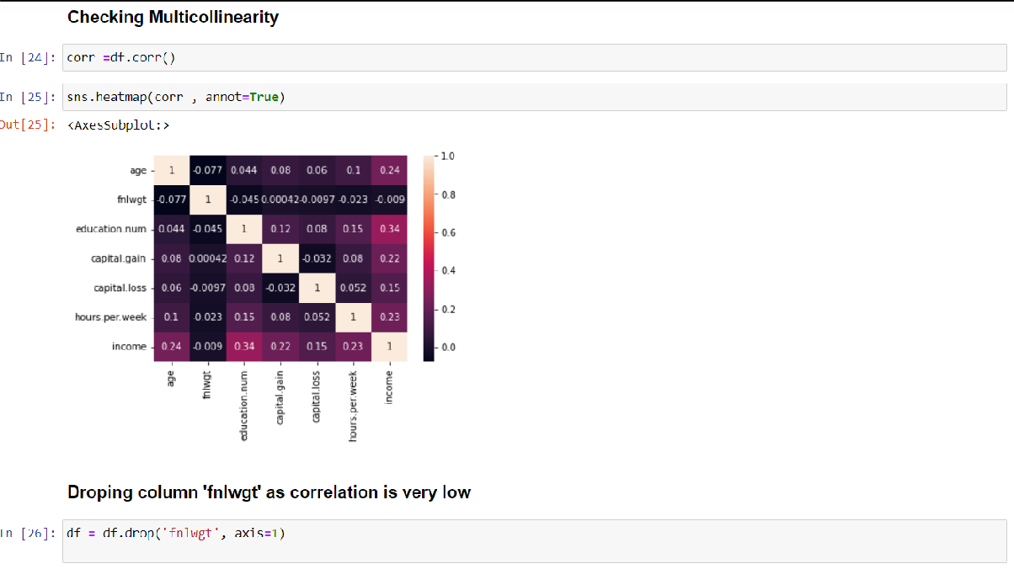



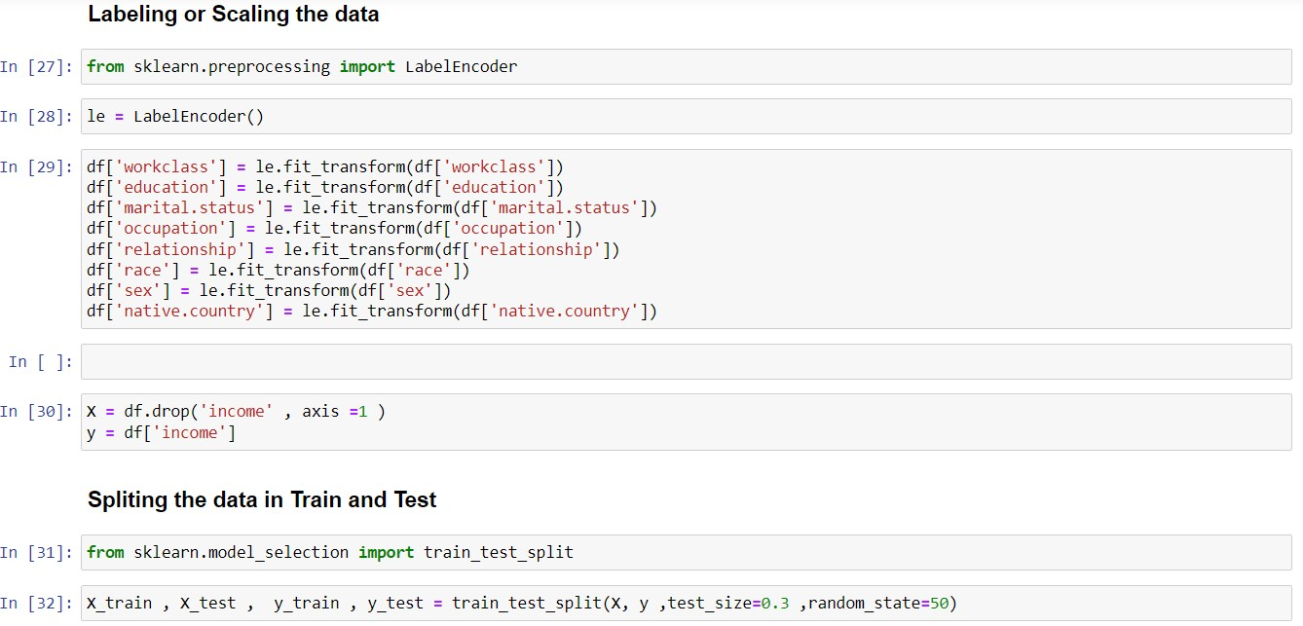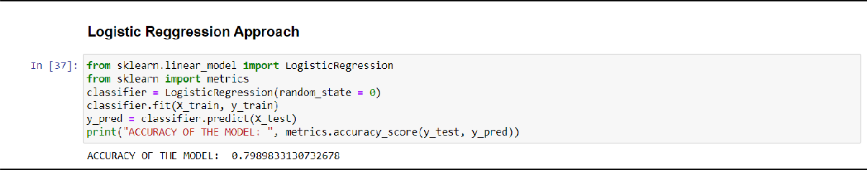

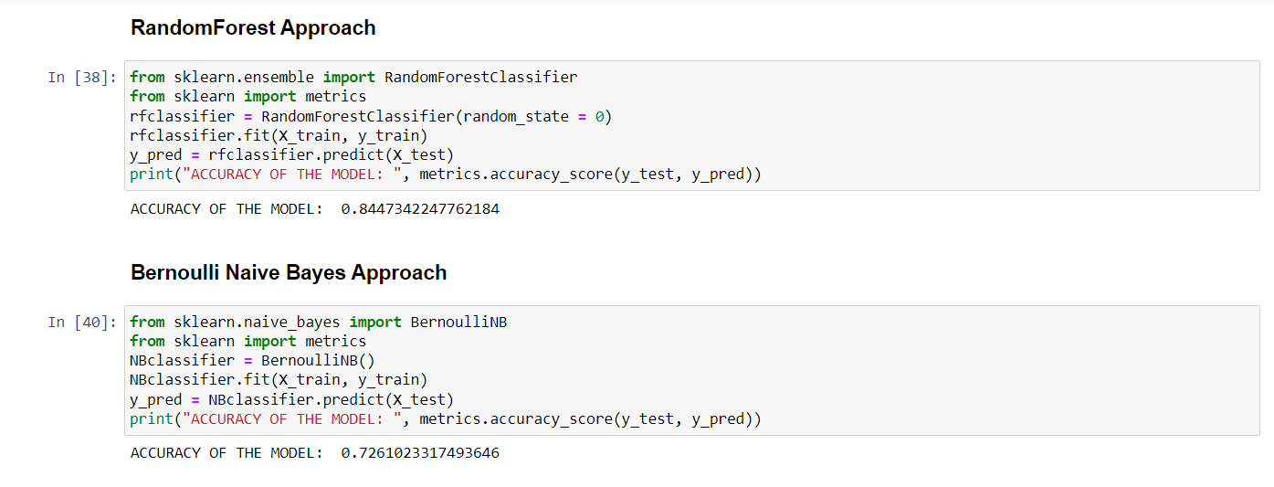

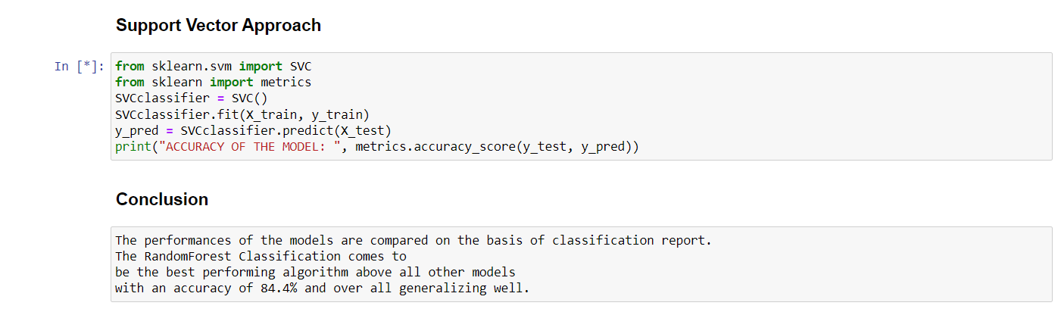

7 REFERENCES

**Kaggle Adult Census Income Data Set** - https://[www.kaggle.com/uciml/adult-census-](http://www.kaggle.com/uciml/adult-census-) income

**Logistic Regression** - https://[www.statisticssolutions.com/what-islogistic-regression/](http://www.statisticssolutions.com/what-islogistic-regression/)